**Eligibility Testing Manual**

**(Left side view-Search Options)**

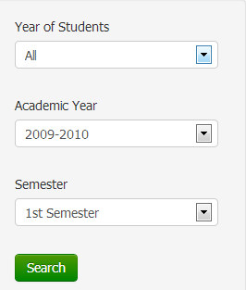

The left side view of this module contains the searching options of the module. When the search button is pressed, the module displays the students based on the options selected.

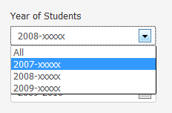

The option ‘Year of Students’ is a dropdown box containing all possible given years of the students with respect to the data uploaded.

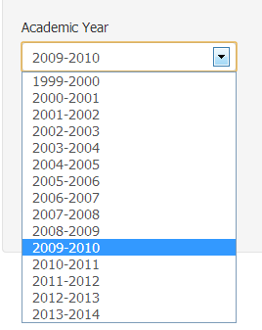

The option ‘Academic Year’ is a dropdown box containing all the possible academic years with respect to the data uploaded.

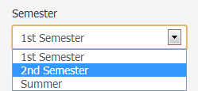

The option ‘Semester’ is a dropdown box containing all the semesters with respect to the data uploaded.

**(Right side view- Students’ Table Display)**

The right side of the module contains the ”generate csv” button, the display option for students and the table displaying the student number, name and the corresponding ineligibility of the student.

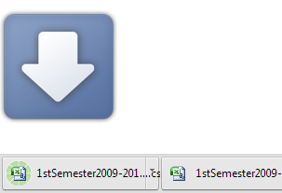

**Generate CSV**

When the download csv button is pressed, a csv file containing the table found on the view is downloaded on the browser.

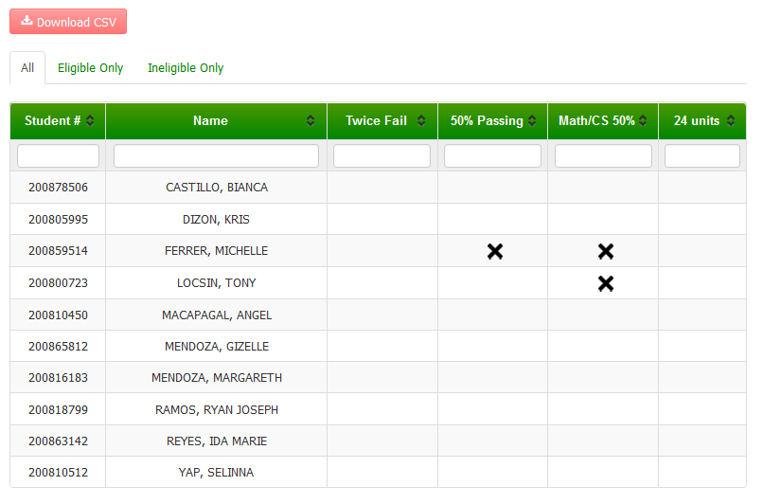

**Display Options of Students:**

‘All’ view selected. All students are shown.

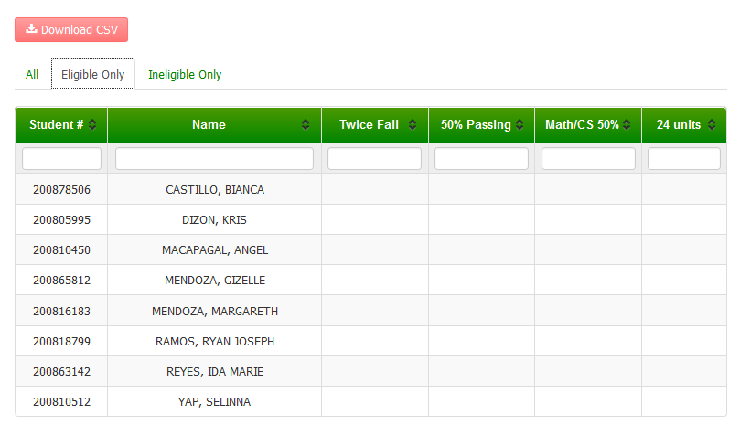

‘Eligible Only” view selected. Only eligible students are shown.

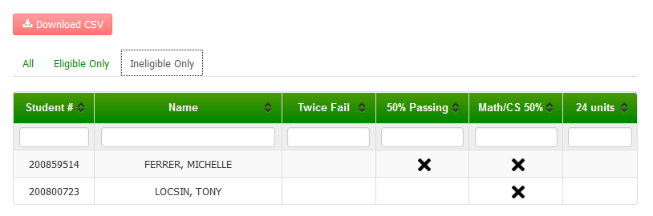

‘Ineligible Only” view selected. Only students with ineligibilities are shown.

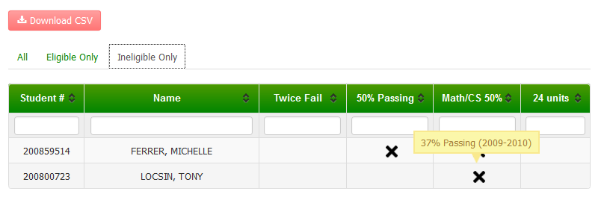**Table Display**

* The table displays the student number, name and corresponding ineligibility of the students based on the option selected
* Each ineligibility is displayed by having an **X** mark on the corresponding ineligibility ­type.
* When you hover on the **X** mark on an ineligibility, a tooltip is displayed showing the information of the corresponding ineligibility.
* Data on the table can be sorted using its columns in the table. One press sorts the table by ascending order and two presses sort the table by descending order with respect to the column attribute pressed.

Sample Screenshot:

(sorted by student number, ascending order)

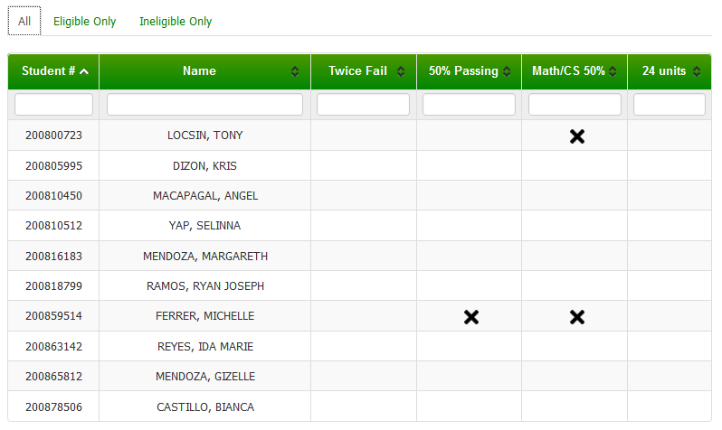

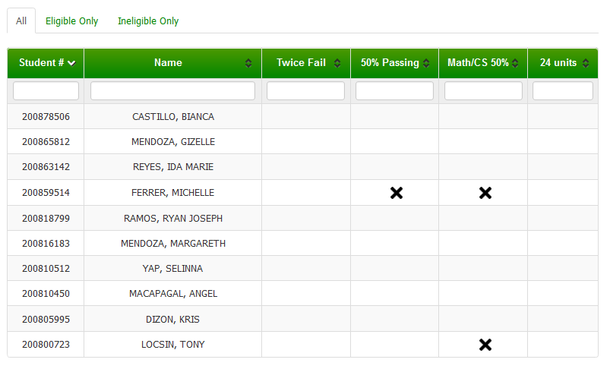(sorted by student number, descending order)